Propel Partners in Wellness
TRACY LARSON, M.Ed., NCSP
Manager, SPECS for PPIW
STEPHEN J. BAGNATO, Ed.D., NCSP
PI, SPECS for PPIW
JANELL SMITH-JONES, Ph.D.
Evaluator/Analyst, PPIW
CAITLIN FORBES SPEARS, Ph.D.
Evaluator/Analyst, PPIW
University of Pittsburgh
Office of Child Development
Psychology-in-Education

Program Evaluation Research Report—Year 1 of PPIW Model

Overview
Purpose
This report is a summary of the intermediate outcomes of the University of Pittsburgh’s Office of Child Development, SPECS for Propel Partners in Wellness program evaluation research of the Propel Charter School’s behavioral health initiative in collaboration with Turtle Creek Valley Community Human Services. The initiative began in the 2016-2017 school year at three Propel schools, with implementation of many components beginning mid-year (i.e., January, 2017) after and active design, implementation and startup phase. This report provides a summary of the data that was collected in year 1 of this evaluation, along with an overview of lessons learned that can be used to inform our formative quality improvement work in years 2 and 3 of PPIW implementation. Data were collected across three critical school-level areas: (a) student screeners, (b) classroom quality, and (c) prevention specialist activities.
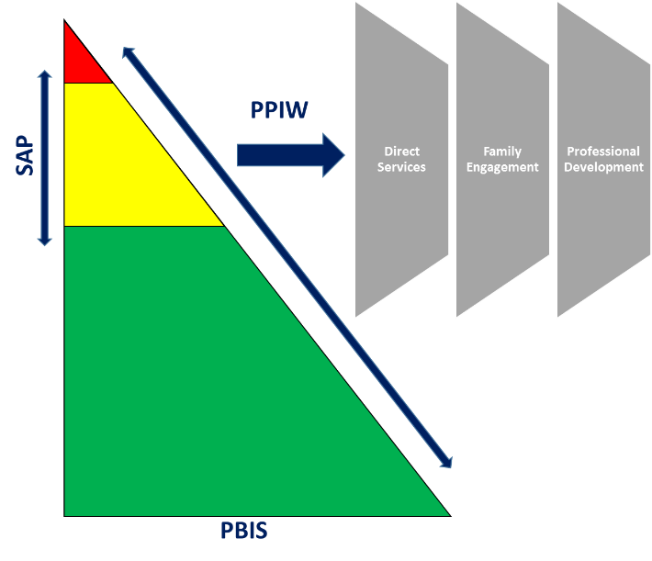
PPIW Model
Propel Partners in Wellness (PPIW) is an innovative school-wide behavioral health intervention pilot initiative for a vulnerable and high-risk urban population of students from grades K-12th. Propel Partners in Wellness uses a Multi-tiered Systems of Support (MTSS; e.g., RTI, PBIS) model (required by PA state and federal government regulations) that encompasses a continuum of broad-based prevention-to-intervention supports to address student, teacher, school climate, and family assets and needs and to promote healthy learning, behavior, interpersonal relationships, school environments, and community-based interagency partnerships.
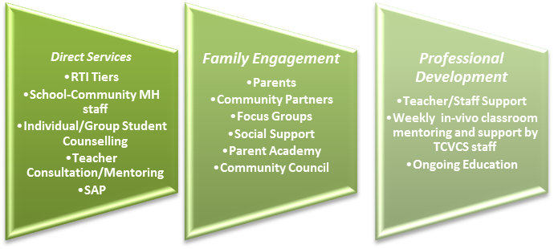
The operational element of the PPIW model is a school-community partnership and teamwork model to engage teachers, support staff, parents/families, and community partners in supporting students so as to promote their healthy behaviors and progress. The Propel Partners in Wellness pilot model engages a partnership between Propel Schools and Turtle Creek Valley Community Services (TCV). The central intervention elements of Propel Partners in Wellness are organized within three overarching pillars:

SPECS Authentic Program Evaluation Research Model
The goals of this evaluation are to (1) document implementation of the key elements of the Propel Partners in Wellness model, including direct services, family engagement, and professional development; (2) examine the interrelations among the three intervention key elements; and (3) assess and analyze the relative effectiveness of the intervention elements on the following outcomes categories: School Climate; Teachers; Students; Family/Parents. Given the complexities involved in implementing a program of this scale, this year 1 summary focuses on the school-level data noted above. The SPECS team collects ongoing natural authentic observation and recordings of actual student performance and classroom teaching practices in-situ in everyday classroom and schools activities and routines. Moreover, SPECS collects information on how the TCVCHS support staff consults with teachers and classroom staff to improve classroom client and to promote student academic and behavioral performance through specific prevention and intervention practices of graduated intensities and strategies.

A. Student Screener Overview

Overall Screener Results
Teachers completed two screening measures at three points across the year (fall, winter, spring)
- The Student Risk Screening Scale (SSRS): Risk for Externalizing Behaviors
- The Student Internalizing Behavior Screening Scale (SIBSS): Risk for Internalizing Behaviors
- Risk levels are categorized as Low (0-3), Moderate (4-8), and High (9-21) across both measures

Cross Schools Externalizing
- Overall screening results indicate relatively stable patterns across the year
- There was a decrease in students identified as at moderate risk across the year
- There was an increase in the number of students identified as at high risk across the year
Exhibit 1: Combined Schools Externalizing Risk Categories across School Year

Exhibit 2:
Cross Schools Percentage of Students in SRSS Externalizing Risk Categories by Grade across Year
Grade | Fall 2016 |  |  |  |  | Winter 2017 |  |  |  |  | Spring 2017
 | Low | Mod. | High | Total |  | Low | Mod. | High | Total |  | Low | Mod. | High | Total
KG | 53 | 13 | 12 | 78 |  | 49 | 13 | 13 | 75 |  | 61 | 5 | 9 | 75
1 | 50 | 15 | 13 | 78 |  | 51 | 13 | 14 | 78 |  | 45 | 12 | 19 | 76
2 | 46 | 19 | 18 | 83 |  | 39 | 21 | 14 | 74 |  | 37 | 21 | 23 | 81
3 | 45 | 18 | 11 | 74 |  | 40 | 15 | 20 | 75 |  | 43 | 18 | 17 | 78
4 | 52 | 16 | 12 | 80 |  | 47 | 11 | 29 | 87 |  | 46 | 18 | 25 | 89
5 | 56 | 24 | 14 | 94 |  | 44 | 21 | 15 | 80 |  | 42 | 29 | 20 | 91
6 | 39 | 28 | 16 | 83 |  | 45 | 19 | 14 | 78 |  | 55 | 8 | 11 | 74
7 | 43 | 38 | 13 | 94 |  | 40 | 27 | 12 | 79 |  | 51 | 26 | 10 | 87
8 | 44 | 26 | 11 | 81 |  | 48 | 20 | 12 | 80 |  | 48 | 21 | 12 | 81
9 | 70 | 32 | 10 | 112 |  | 67 | 28 | 20 | 115 |  | 17 | 9 | 6 | 32
10 | 32 | 20 | 11 | 63 |  | 48 | 27 | 12 | 87 |  | 41 | 26 | 11 | 78
11 | 43 | 10 | 8 | 61 |  | 41 | 20 | 6 | 67 |  | 39 | 11 | 3 | 53
12 | 23 | 24 | 5 | 52 |  | 25 | 20 | 14 | 59 |  | 10 | 17 | 13 | 40
Exhibit 3: Combined Schools Overall Externalizing Risk across School Year by Grade
- Grades KG, 6, 7, 8, 9, and 11 have a decrease in overall externalizing risk by the end of the year
- Grades 1-5, 10 and 12 have an increase in children with externalizing risk across the year
- Grades 1, 8, 11, and 12 were relatively stable regardless of direction of change across the year

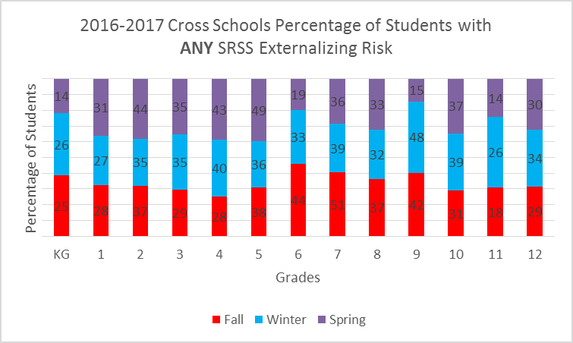

Cross Schools Externalizing by Grade
Cross Schools Internalizing
Exhibit 4: Combined Schools Internalizing Risk Categories across School Year
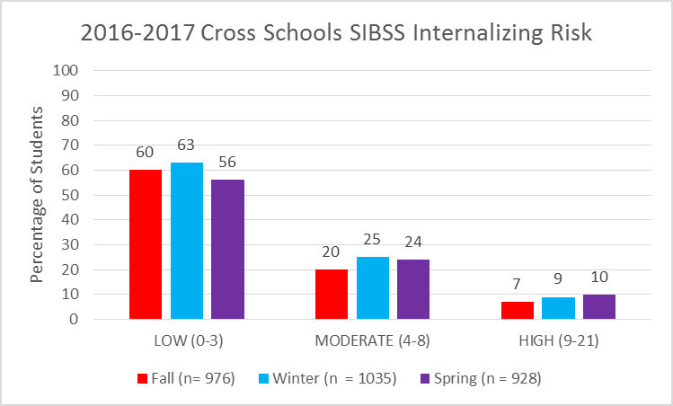
- Overall screening results indicate relatively stable patterns across the year
- There were slight increases in students identified as at moderate and high risk across the year
- There was a swell in the number of students who were screened at winter, followed by a large drop at spring

Cross Schools Internalizing by Grade
Exhibit 5:
Cross Schools Percentage of Students in SIBSS Internalizing Risk Categories by Grade across Year
Grade | Fall 2016 |  |  |  |  | Winter 2017 |  |  |  |  | Spring 2017
 | Low | Mod. | High | Total |  | Low | Mod. | High | Total |  | Low | Mod. | High | Total
KG | 43 | 9 | 5 | 57 |  | 58 | 17 | 1 | 76 |  | 70 | 6 | 1 | 76
1 | 66 | 10 | 1 | 77 |  | 65 | 11 | 1 | 77 |  | 65 | 8 | 1 | 76
2 | 64 | 18 | 1 | 83 |  | 27 | 27 | 4 | 58 |  | 40 | 30 | 4 | 77
3 | 42 | 12 | 2 | 56 |  | 53 | 13 | 10 | 76 |  | 57 | 15 | 10 | 77
4 | 52 | 22 | 10 | 84 |  | 49 | 20 | 17 | 86 |  | 31 | 36 | 17 | 88
5 | 66 | 24 | 2 | 92 |  | 65 | 8 | 7 | 80 |  | 58 | 24 | 7 | 94
6 | 38 | 32 | 8 | 78 |  | 57 | 3 | 3 | 78 |  | 59 | 11 | 3 | 75
7 | 72 | 26 | 6 | 104 |  | 56 | 17 | 7 | 80 |  | 67 | 20 | 7 | 83
8 | 48 | 28 | 8 | 84 |  | 57 | 20 | 3 | 80 |  | 57 | 14 | 3 | 81
9 | 77 | 26 | 8 | 111 |  | 67 | 38 | 9 | 114 |  | 16 | 11 | 9 | 30
10 | 36 | 13 | 12 | 61 |  | 47 | 30 | 8 | 88 |  | 39 | 29 | 8 | 78
11 | 35 | 17 | 2 | 54 |  | 40 | 16 | 11 | 67 |  | 39 | 10 | 11 | 53
12 | 33 | 12 | 6 | 51 |  | 29 | 23 | 7 | 59 |  | 21 | 11 | 7 | 40
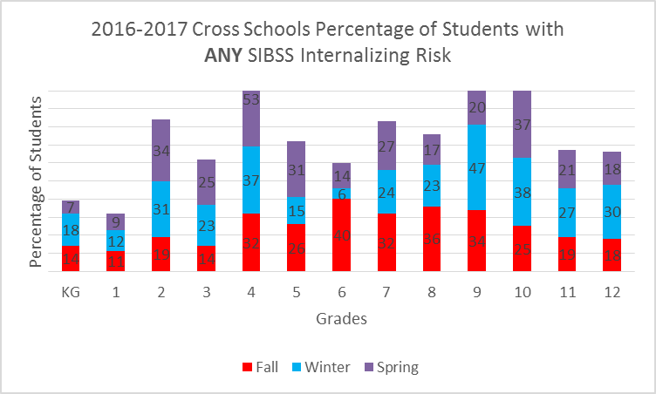
- Grades KG -1, and 6-9 have a decrease in overall internalizing risk by the end of the year
- Grades 2-5 and 10-12 have an increase in children with internalizing risk across the year
- Grades KG, 1, 11, and 12 were relatively stable regardless of direction of change across the year
Exhibit 6: Combined Schools Overall Externalizing Risk across School Year by Grade
Screener Results by School
School 1: K-8
School 1 Externalizing
Exhibit 7: School 1 Externalizing Risk Categories across School Year
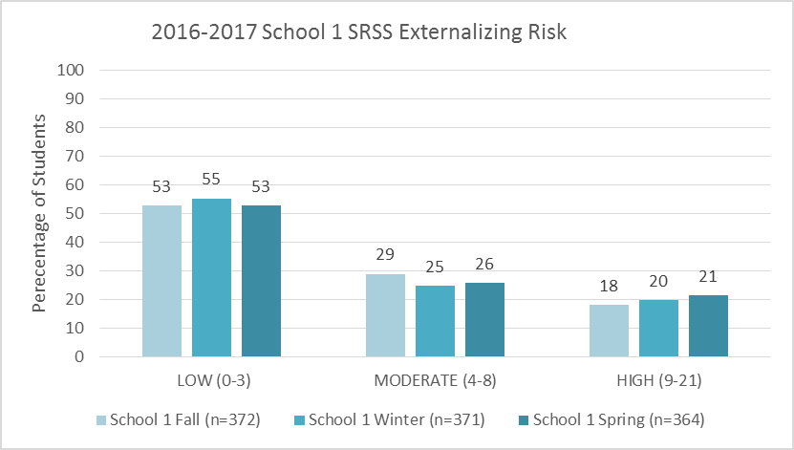

- The number of students screened across the year was generally consistent
- School 1 screening results indicate relatively stable patterns across the year
- There was a decrease in students identified as at moderate risk across the year
- There was an increase in the number of students identified as at high risk across the year
School 1 Externalizing by Grade
Exhibit 8:
School 1 Cross Year Percentage of Students in SRSS Externalizing Risk Categories by Grade
Grade | Fall 2016 |  |  |  |  | Winter 2017 |  |  |  |  | Spring 2017
 | Low | Mod. | High | Total |  | Low | Mod. | High | Total |  | Low | Mod. | High | Total
KG | 20 | 7 | 10 | 37 |  | 22 | 7 | 8 | 37 |  | 23 | 5 | 9 | 37
1 | 28 | 9 | 5 | 42 |  | 26 | 4 | 10 | 40 |  | 15 | 11 | 12 | 38
2 | 12 | 13 | 15 | 40 |  | 16 | 14 | 10 | 40 |  | 9 | 14 | 18 | 41
3 | 16 | 10 | 6 | 32 |  | 15 | 11 | 11 | 37 |  | 19 | 11 | 9 | 39
4 | 31 | 9 | 2 | 42 |  | 39 | 3 | 2 | 44 |  | 35 | 5 | 4 | 44
5 | 25 | 16 | 5 | 46 |  | 20 | 16 | 9 | 45 |  | 20 | 16 | 5 | 41
6 | 14 | 14 | 11 | 39 |  | 16 | 14 | 12 | 42 |  | 22 | 7 | 9 | 38
7 | 29 | 16 | 7 | 52 |  | 24 | 16 | 5 | 45 |  | 32 | 10 | 3 | 45
8 | 21 | 14 | 7 | 42 |  | 27 | 7 | 7 | 41 |  | 17 | 15 | 9 | 41
Exhibit 9: School 1 Overall Externalizing Risk across School Year by Grade

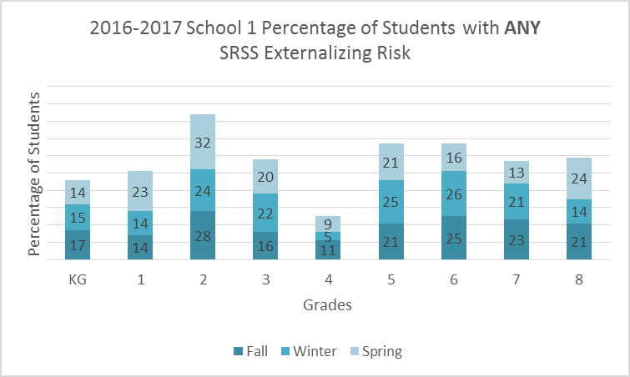

- Grades KG, 4, 6, and 7 have a decrease by the end of the year
- Grades 1-3 and 8 have an increase in children with externalizing risk across the year
- Multiple grades have relatively stable levels of externalizing risk across the year
- Multiple grades either dip or swell at winter then return to fall levels by spring

School 1 Internalizing
Exhibit 10: School 1 Internalizing Risk Categories across School Year
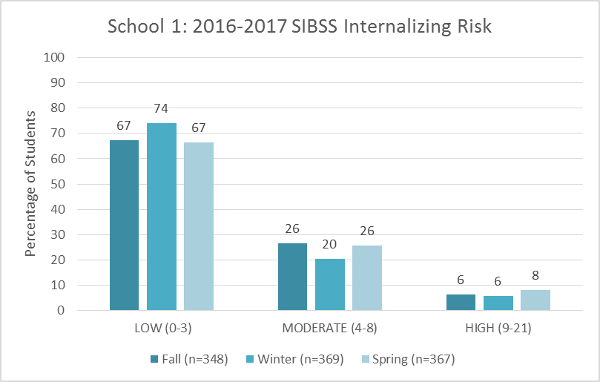
- The number of students screened across the year was generally consistent and increased by the end of the year
- There was a dip in the number of students identified as at moderate risk in the winter, but these numbers rose back to baseline levels in the spring.
- There was a slight increase in students identified as at high risk across the year, but these numbers were low and relatively stable
School 1 Internalizing by Grade
Exhibit 11:
School 1 Cross Year Percentage of Students in SIBSS Internalizing Risk Categories by Grade
Grade | Fall 2016 |  |  |  |  | Winter 2017 |  |  |  |  | Spring 2017
 | Low | Mod. | High | Total |  | Low | Mod. | High | Total |  | Low | Mod. | High | Total
KG | 12 | 2 | 4 | 18 |  | 28 | 7 | 1 | 36 |  | 32 | 4 |  | 36
1 | 37 | 4 | 0 | 41 |  | 33 | 6 | 1 | 40 |  | 31 | 8 | 2 | 39
2 | 26 | 14 | 0 | 40 |  | 19 | 16 | 4 | 39 |  | 15 | 21 | 5 | 41
3 | 21 | 6 | 1 | 28 |  | 28 | 6 | 4 | 38 |  | 32 | 6 | 1 | 39
4 | 26 | 11 | 5 | 42 |  | 37 | 5 | 1 | 43 |  | 24 | 16 | 3 | 43
5 | 33 | 12 | 1 | 46 |  | 36 | 5 | 4 | 45 |  | 27 | 13 | 4 | 44
6 | 19 | 16 | 4 | 39 |  | 27 | 13 | 2 | 42 |  | 26 | 9 | 4 | 39
7 | 36 | 13 | 3 | 52 |  | 38 | 5 | 2 | 45 |  | 34 | 9 | 2 | 45
8 | 24 | 14 | 4 | 42 |  | 27 | 12 | 2 | 41 |  | 23 | 10 | 8 | 41
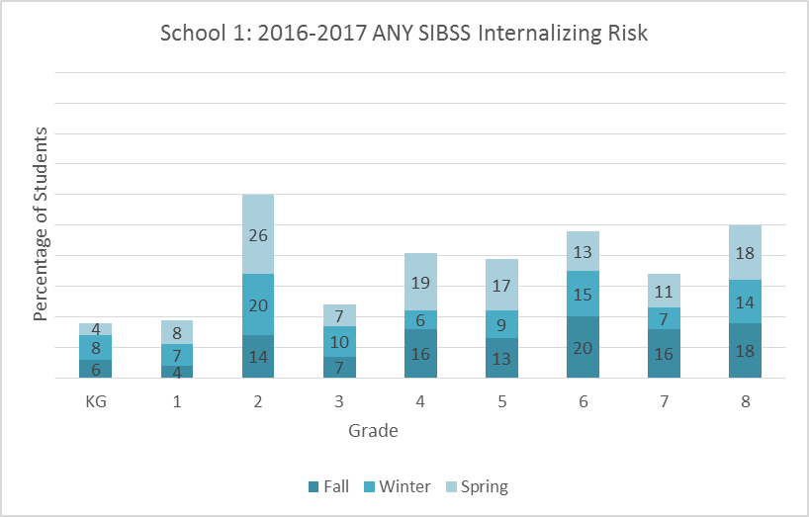
- Grades KG, 6, and 7 have a decrease by the end of the year
- Grades 1-5 have an increase in children with internalizing risk across the year
- Multiple grades either dip or swell at winter
Exhibit 12: School 1 Overall Internalizing Risk across School Year by Grade
School 2: K-8
School 2 Externalizing
Exhibit 13: School 2 Externalizing Risk Categories across School Year
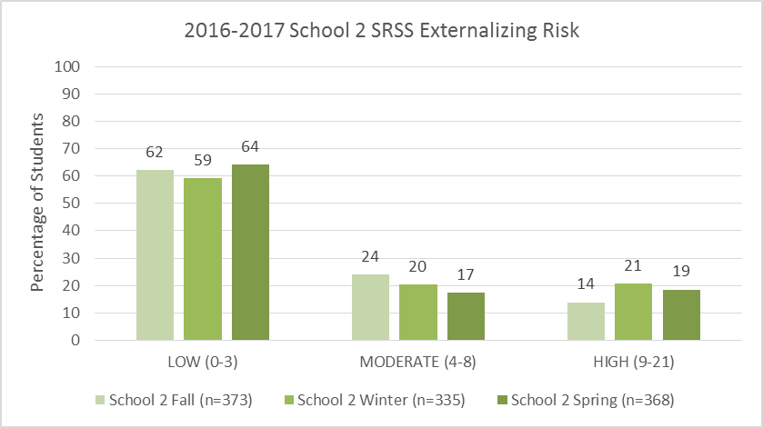

- The number of students screened across the year was generally consistent
- There was a decrease in students identified as at moderate risk across the year
- There was an increase in the number of students identified as at high risk across the year
- This number dropped from the high at the winter time point
School 2 Externalizing by Grade
Exhibit 14:
School 2 Cross Year Percentage of Students in SRSS Externalizing Risk Categories by Grade
Grade | Fall 2016 |  |  |  |  | Winter 2017 |  |  |  |  | Spring 2017
 | Low | Mod. | High | Total |  | Low | Mod. | High | Total |  | Low | Mod. | High | Total
KG | 33 | 6 | 2 | 41 |  | 27 | 6 | 5 | 38 |  | 38 | 0 | 0 | 38
1 | 22 | 6 | 8 | 36 |  | 25 | 9 | 4 | 38 |  | 30 | 1 | 7 | 38
2 | 34 | 6 | 3 | 43 |  | 23 | 7 | 4 | 34 |  | 28 | 7 | 5 | 40
3 | 29 | 8 | 5 | 42 |  | 25 | 4 | 9 | 38 |  | 24 | 7 | 8 | 39
4 | 21 | 7 | 10 | 38 |  | 8 | 8 | 27 | 43 |  | 11 | 13 | 21 | 45
5 | 31 | 8 | 9 | 48 |  | 24 | 5 | 6 | 35 |  | 22 | 13 | 15 | 50
6 | 25 | 14 | 5 | 44 |  | 29 | 5 | 2 | 36 |  | 33 | 1 | 2 | 36
7 | 14 | 22 | 6 | 42 |  | 16 | 11 | 7 | 34 |  | 19 | 16 | 7 | 42
8 | 23 | 12 | 4 | 39 |  | 21 | 13 | 5 | 39 |  | 31 | 6 | 3 | 40
Exhibit 15: School 2 Overall Externalizing Risk across School Year by Grade

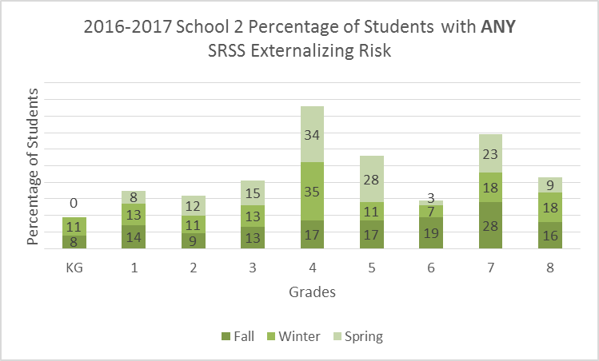

- Grades KG, 1, 6, and 8 have a decrease by the end of the year
- Grades 4, 5, and 7 have an increase in children with externalizing risk across the year
- Grades 2 and 3 appear to have relatively stable levels of externalizing risk across the year

School 2 Internalizing
Exhibit 16: School 2 Internalizing Risk Categories across School Year
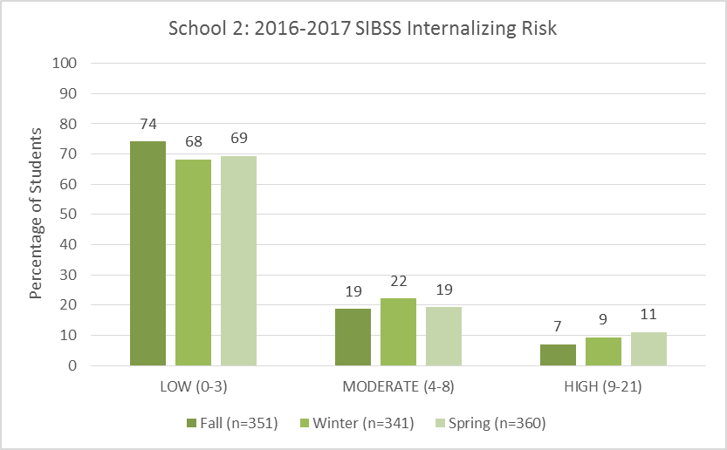
- The number of students screened across the year was generally consistent and increased by the end of the year
- The number of students identified as at moderate risk was relatively stable across the year
- There was a slight increase in students identified as at high risk across the year, but these numbers were low and relatively stable

School 2 Internalizing by Grade
Exhibit 17:
School 2 Cross Year Percentage of Students in SIBSS Internalizing Risk Categories by Grade
Grade | Fall 2016 |  |  |  |  | Winter 2017 |  |  |  |  | Spring 2017
 | Low | Mod. | High | Total |  | Low | Mod. | High | Total |  | Low | Mod. | High | Total
KG | 31 | 7 | 1 | 39 |  | 30 | 10 | 0 | 40 |  | 38 | 2 |  | 40
1 | 29 | 6 | 1 | 36 |  | 32 | 5 | 0 | 37 |  | 34 | 2 | 1 | 37
2 | 38 | 4 | 1 | 43 |  | 27 | 11 | 0 | 38 |  | 25 | 9 | 2 | 36
3 | 21 | 6 | 1 | 28 |  | 25 | 7 | 6 | 38 |  | 25 | 9 | 4 | 38
4 | 26 | 11 | 5 | 42 |  | 12 | 15 | 16 | 43 |  | 7 | 20 | 18 | 45
5 | 33 | 12 | 1 | 46 |  | 29 | 3 | 3 | 35 |  | 31 | 11 | 8 | 50
6 | 19 | 16 | 4 | 39 |  | 30 | 5 | 1 | 36 |  | 33 | 2 | 1 | 36
7 | 36 | 13 | 3 | 52 |  | 18 | 12 | 5 | 35 |  | 23 | 11 | 4 | 38
8 | 24 | 14 | 4 | 42 |  | 30 | 8 | 1 | 39 |  | 34 | 4 | 2 | 40
Exhibit 18: School 2 Overall Internalizing Risk across School Year by Grade
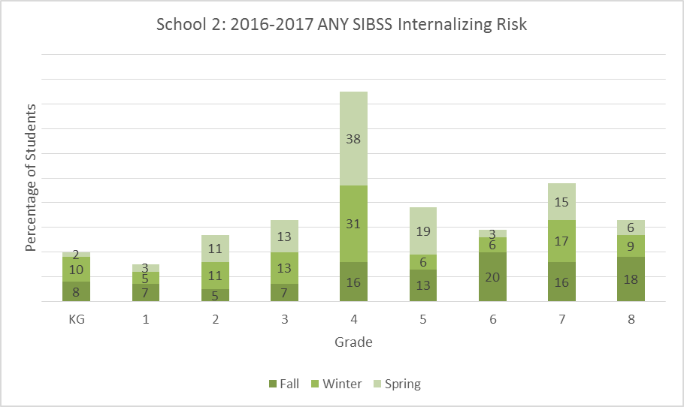
- Grades KG-1, and 6- 8 have a decrease by the end of the year
  - Grades KG, 6, and 8 drop by more than 5%
- Grades 2-5 have an increase in children with internalizing risk across the year

School 3: 9th-12th
School 3 Externalizing
Exhibit 19: School 3 Externalizing Risk Categories across School Year
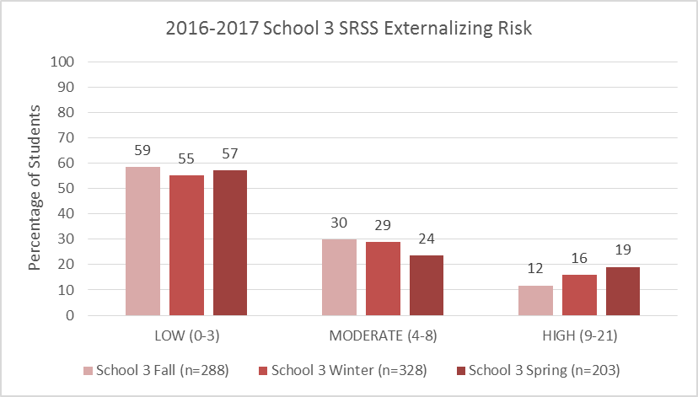

- There was a decrease in students identified as at moderate risk across the year
- The number of students at low risk was relatively stable across the year
- There was an increase in the number of students identified as at high risk across the year
- The number of students screened across the year dropped significantly at spring

School 3 Externalizing
Exhibit 20:
School 3 Cross Year Percentage of Students in SRSS Externalizing Risk Categories by Grade
Grade | Fall 2016 |  |  |  |  | Winter 2017 |  |  |  |  | Spring 2017
 | Low | Mod. | High | Total |  | Low | Mod. | High | Total |  | Low | Mod. | High | Total
9 | 70 | 32 | 10 | 110 |  | 67 | 28 | 20 | 115 |  | 17 | 9 | 6 | 32
10 | 32 | 20 | 11 | 63 |  | 48 | 27 | 12 | 87 |  | 41 | 26 | 11 | 78
11 | 43 | 10 | 8 | 61 |  | 41 | 20 | 6 | 67 |  | 39 | 11 | 3 | 53
12 | 23 | 24 | 5 | 52 |  | 25 | 20 | 14 | 59 |  | 10 | 17 | 13 | 40
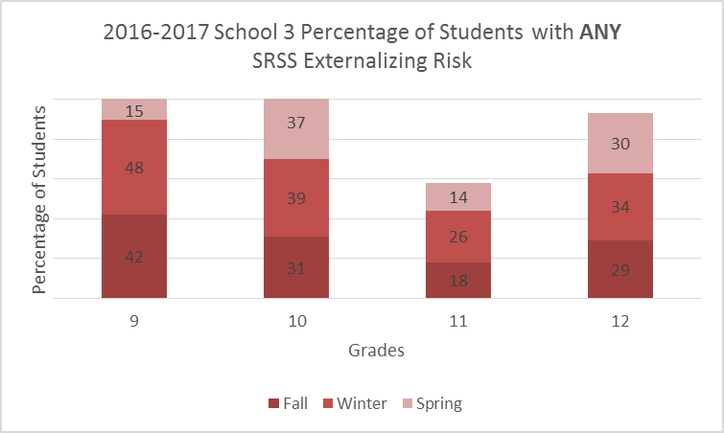
- Grades 9 and 11 have a decrease by the end of the year
- Grade 12 appears to have relatively stable levels of externalizing risk across the year
- Grade 10 has an increase in children with externalizing risk across the year
Exhibit 21: School 3 Overall Externalizing Risk across School Year by Grade
School 3 Internalizing

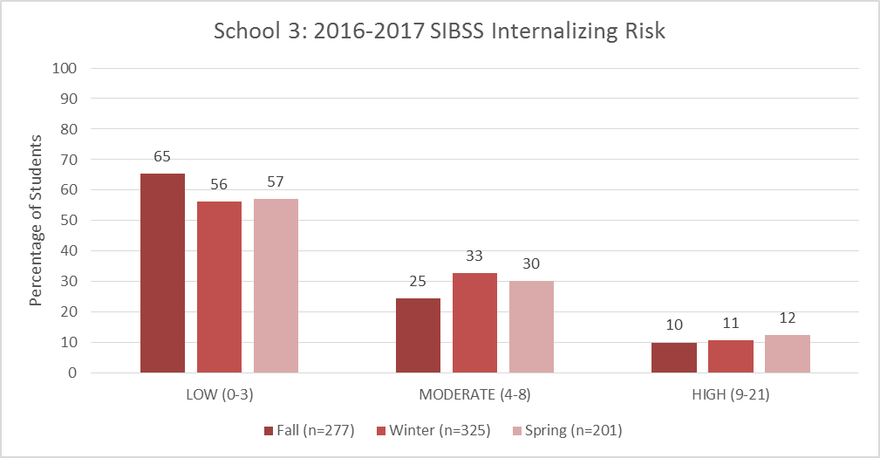
- The number of students identified as at moderate risk increased at winter, but did drop down below that level by spring
- There was a slight increase in students identified as at high risk across the year, but these numbers were low and relatively stable
- The number of students screened increased at winter but then dropped to below fall levels by spring
Exhibit 22: School 3 Internalizing Risk Categories across School Year
School 3 Internalizing by Grade
Exhibit 23:
School 3 Cross Year Percentage of Students in SIBSS Internalizing Risk Categories by Grade
Grade | Fall 2016 |  |  |  |  | Winter 2017 |  |  |  |  | Spring 2017
 | Low | Mod. | High | Total |  | Low | Mod. | High | Total |  | Low | Mod. | High | Total
9 | 77 | 26 | 8 | 111 |  | 67 | 38 | 9 | 114 |  | 16 | 11 | 3 | 30
10 | 36 | 13 | 12 | 61 |  | 47 | 30 | 8 | 85 |  | 39 | 29 | 10 | 78
11 | 35 | 17 | 2 | 54 |  | 40 | 16 | 11 | 67 |  | 39 | 10 | 4 | 53
12 | 33 | 12 | 6 | 51 |  | 29 | 23 | 7 | 59 |  | 21 | 11 | 8 | 40
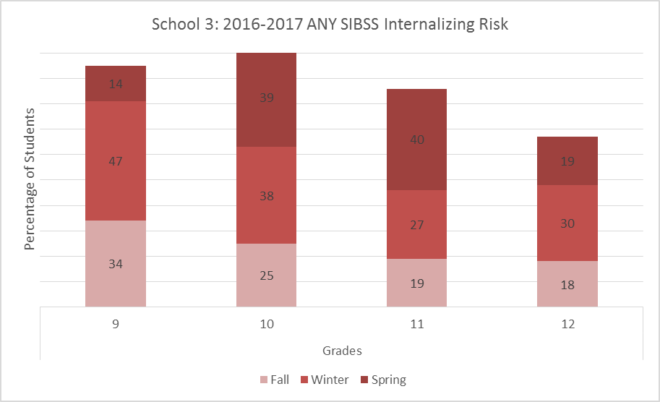
- Grades 9 had a decrease by the end of the year
- Grade 12 appears to have relatively stable levels of internalizing risk across the year
- Grades 10 and 11 had an increase in children with externalizing risk across the year

Exhibit 24: School 3 Overall Internalizing Risk across School Year by Grade
B. Classroom Overview
Overall CLASS Results
We observed 42 classrooms across all three schools in the fall of 2016.
- 27 classrooms were identified based on a high incidence of ODRs
  - Classrooms that were identified based on ODRS are marked with an asterisk below in the school-level analyses
- 15 classrooms were identified for general observation
- 1 classroom was dropped from analyses due to incomplete data
We used the Classroom Assessment Scoring System (CLASS), which measures classroom quality via interactions across multiple domains. Given that the PPIW model targets behavior management and supports, we are focusing on the Classroom Organization domain.
  - CLASS observations use different versions based on grade level.
  - Given our focus on school-level differences, we report these as a single construct, “Classroom Organization”. All dimensions are reported for classrooms in the school-level analysis, however the actual domain score reflects the CLASS version that was used for the observation.
Exhibit 25:
Classroom Organization Domains by Grade Level
 | Dimension | Components | Quality Rating
KG-3 Classroom Organization Domain | Behavior Management | Clear behavior expectations | Low  (1-2) | Moderate (3-5) | High  (6-7)
 |  | Proactive
 |  | Redirection of misbehavior
 |  | Student behavior
 | Productivity | Maximizing learning time | Low (1-2) | Moderate (3-5) | High  (6-7)
 |  | Routines
 |  | Transitions
 |  | Preparation
 | Instructional Learning Formats | Effective facilitation | Low (1-2) | Moderate (3-5) | High  (6-7)
 |  | Variety of modalities and materials
 |  | Student interest
 |  | Clarity of learning objectives
4-6 and 7-12  Classroom Organization Domain | Behavior Management | Clear behavior expectations | Low  (1-2) | Moderate (3-5) | High  (6-7)
 |  | Proactive
 |  | Redirection of misbehavior
 |  | Student behavior
 | Productivity | Maximizing learning time | Low  (1-2) | Moderate (3-5) | High  (6-7)
 |  | Routines
 |  | Transitions
 |  | Preparation
 | Negative Climate | Negative affect | Low  (1-2) | Moderate (3-5) | High  (6-7)
 |  | Punitive control
 |  | Disrespect
Note. Negative Climate is reversed scored.

Cross Schools
Exhibit 26: Combined Schools CLASS Results
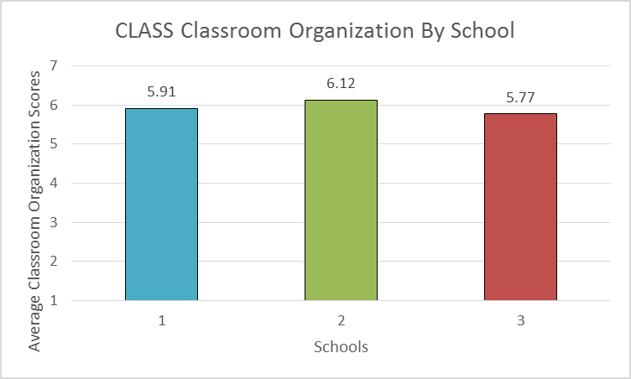

Exhibit 27:
Classroom Organization Dimension Scores by School
Classroom ID |  |  | Classroom Organization Dimensions |  |  | Classroom Organization Domain Score
 | Behavior Management | Productivity |  | Negative Climate | Instructional Learning Formats
School 1 | 5.52 | 5.71 |  | 6.79 | 5.32 | 5.91
School 2 | 5.73 | 6.20 |  | 6.42 | 5.91 | 6.12
School 3 | 5.25 | 5.62 |  | 5.94 | 5.31 | 5.77
- Overall, all three schools are providing moderate (scores of 3-5) to high (scores of 6-7) quality interactions that support classroom organization.
- Across schools, these scores are largely consistent across all dimensions
  - Behavior Management and Instructional Learning Format scores are moderate across all three schools
  - School 1 has a strong moderate score on Productivity, and a high score on Negative Climate
  - School 2 has high scores on the overall domain, as well as in Productivity and Negative Climate
  - School 3 has moderate scores on Productivity and Negative Climate

CLASS Results by School
School 1: K-8
Exhibit 28: School 1 CLASS Results
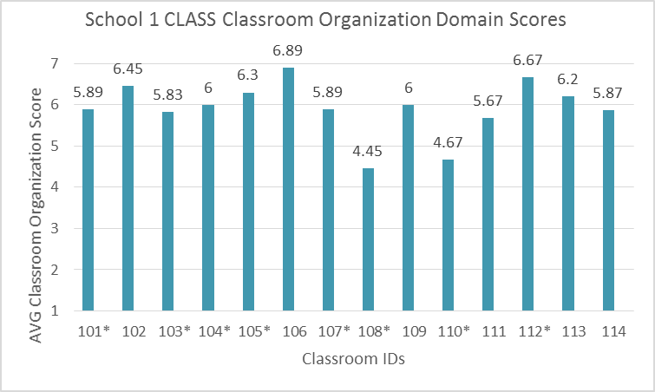

Exhibit 29:
School 1 Classroom Organization Dimension Scores by Classroom
Classroom ID | Classroom Organization Dimensions |  |  |  | Classroom Organization Domain Score
 | Behavior Management | Productivity | Negative Climate | Instructional Learning Formats
101* | 6.00 | 5.67 | 6.67 | 6.00 | 5.89
102 | 6.00 | 6.67 | 7.00 | 6.67 | 6.45
103* | 5.50 | 6.00 | 7.00 | 6.00 | 5.83
104* | 6.00 | 6.00 | 7.00 | 6.00 | 6.00
105* | 6.60 | 6.30 | 7.00 | 6.00 | 6.30
106 | 7.00 | 6.67 | 7.00 | 5.67 | 6.89
107* | 5.67 | 5.00 | 7.00 | 4.00 | 5.89
108* | 2.67 | 4.00 | 6.67 | 3.67 | 4.45
109 | 5.33 | 5.67 | 7.00 | 5.00 | 6.00
110* | 4.33 | 4.67 | 5.00 | 3.33 | 4.67
111 | 5.33 | 5.00 | 6.67 | 6.00 | 5.67
112* | 7.00 | 6.00 | 7.00 | 5.60 | 6.67
113 | 5.30 | 6.30 | 7.00 | 6.60 | 6.20
114 | 4.60 | 6.00 | 7.00 | 4.00 | 5.87
Total Scores | 5.52 | 5.71 | 6.79 | 5.32 | 5.91
- 50% of School 1 classrooms received high quality scores
- 50% of School 1 classrooms received moderate quality scores
- Across dimensions, we see the following patterns:
  - Behavior Management: Low (7%), Moderate (50%), High (43%)
  - Productivity: Moderate (43%), High (57%)
  - Negative Climate: Moderate (7%), High (93%)
  - Instructional Learning Formats: Moderate (50%), High (50%)
School 2: K-8th
Exhibit 30: School 2 CLASS Results
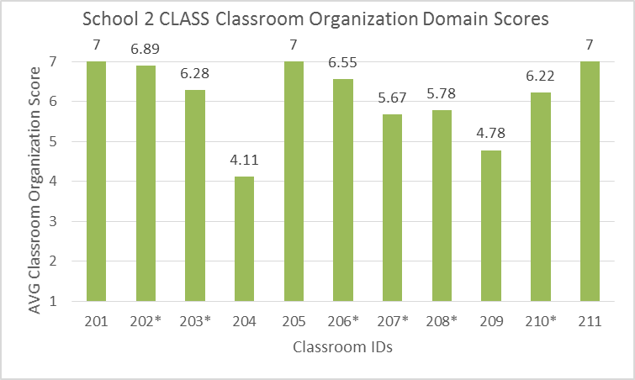

Exhibit 31:
School 2 Classroom Organization Dimension Scores by Classroom
Classroom ID | Classroom Organization Dimensions |  |  |  | Classroom Organization Domain Score
 | Behavior Management | Productivity | Negative Climate | Instructional Learning Formats
201 | 7.00 | 7.00 | 7.00 | 7.00 | 7.00
202* | 7.00 | 7.00 | 7.00 | 6.67 | 6.89
203* | 6.33 | 6.50 | 5.67 | 6.00 | 6.28
204 | 3.00 | 6.00 | 3.33 | 4.33 | 4.11
205 | 7.00 | 7.00 | 7.00 | 7.00 | 7.00
206* | 6.33 | 7.00 | 6.33 | 6.00 | 6.55
207* | 4.33 | 5.67 | 7.00 | 5.33 | 5.67
208* | 5.33 | 5.00 | 7.00 | 5.67 | 5.78
209 | 3.67 | 4.33 | 6.33 | 4.33 | 4.78
210* | 6.00 | 5.67 | 7.00 | 5.67 | 6.22
211 | 7.00 | 7.00 | 7.00 | 7.00 | 7.00
Total Scores | 5.73 | 6.20 | 6.42 | 5.91 | 6.12
- 64% of School 2 classrooms received high quality scores
- 36% of School 2 classrooms received moderate quality scores
- Across dimensions, we see the following patterns:
  - Behavior Management: Moderate (36%), High (64%)
  - Productivity: Moderate (36%), High (64%)
  - Negative Climate: Moderate (18%), High (82%)
  - Instructional Learning Formats: Moderate (45%), High (55%)
School 3: 9-12th
Exhibit 32: School 3 CLASS Results
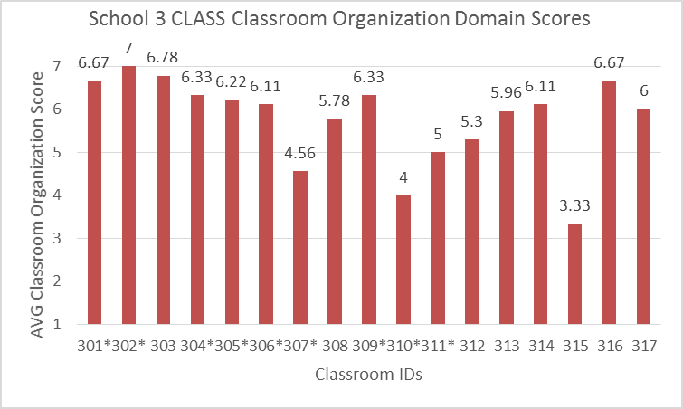

Exhibit 33:
School 3 Classroom Organization Dimension Scores by Classroom
Classroom ID | Classroom Organization Dimensions |  |  |  | Classroom Organization Domain Score
 | Behavior Management | Productivity | Negative Climate | Instructional Learning Formats
301* | 6.00 | 7.00 | 7.00 | 6.33 | 6.67
302* | 7.00 | 7.00 | 7.00 | 6.00 | 7.00
303 | 7.00 | 6.67 | 6.67 | 5.67 | 6.78
304* | 5.67 | 6.33 | 7.00 | 5.67 | 6.33
305* | 6.67 | 5.00 | 7.00 | 4.33 | 6.22
306* | 5.67 | 6.33 | 6.33 | 5.33 | 6.11
307* | 3.00 | 3.67 | 7.00 | 4.00 | 4.56
308 | 5.00 | 6.00 | 6.33 | 5.67 | 5.78
309* | 6.33 | 6.33 | 6.33 | 6.33 | 6.33
310* | 2.00 | 3.00 | 7.00 | 3.33 | 4.00
311* | 4.33 | 3.67 | 7.00 | 3.67 | 5.00
312 | 5.30 | 5.00 | 6.30 | 6.00 | 5.30
313 | 5.60 | 5.60 | 1.30 | 5.60 | 5.96
314 | 5.33 | 7.00 | 6.00 | 5.67 | 6.11
315 | 2.00 | 4.00 | 4.00 | 4.33 | 3.33
316 | 6.33 | 7.00 | 6.67 | 6.33 | 6.67
317 | 6.00 | 6.00 | 2.00 | 6.00 | 6.00
Total Scores | 5.25 | 5.62 | 5.94 | 5.31 | 5.77
- 59% of School 3 classrooms received high quality scores
- 41% of School 1 classrooms received moderate quality scores
- Across dimensions, we see the following patterns:
  - Behavior Management: Low (12%), Moderate (47%), High (41%)
  - Productivity: Moderate (41%), High (59%)
  - Negative Climate: Low (12%), Moderate (6%), High (82%)
  - Instructional Learning Formats: Moderate (41%), High (59%)
By Age Group

Exhibit 34: Across School CLASS Results by Age Group
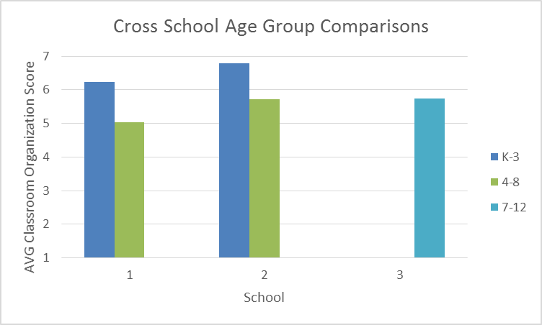

Exhibit 35:
Cross School Average Classroom Organization Dimension Scores by Age Group
School | Age Range | Classroom Organization Dimensions |  |  |  | Classroom Organization Domain Score
 |  | Behavior Management | Productivity | Negative Climate | Instructional Learning Formats
1 | K-3 | 6.18 | 6.22 | 6.95 | 6.06 | 6.23
1 | 4-8 | 5.33 | 4.78 | 6.67 | 5.03 | 5.03
2 | K-3 | 6.83 | 6.88 | 6.67 | 6.67 | 6.8
2 | 4-8 | 5.09 | 5.81 | 6.28 | 5.48 | 5.73
3 | 9-12 | 5.25 | 5.62 | 5.94 | 5.31 | 5.77
- In both Schools 1 and 1, KG-3 classrooms received high quality scores across the board
- Across all schools, upper elementary and secondary classrooms received more variable scores.

C. Prevention Specialist Logs
Overall Prevention Specialist Log Results
Prevention Specialists completed 372 entries across the three participating schools
  - Data were collected from January to June.
Exhibit 36:
Combined Schools Log Summary
Activity Description | Activity | Time (hrs.)
Child s-e summaries, classroom summaries, reports, child or met plans, implementation checklists, progress notes, activity log. | DOCUMENTATION | 461.55
Visual supports, behavior charts, social emotional lesson/activity materials, informational handouts, newsletters, research articles, etc… | PLANNING/ PREPARATION | 276.25
Grade level meetings, All Staff Meetings, Trainings, Parent groups | PROFESSIONAL DEVELOPMENT | 212.15
 | SAP CONSULATIONS/MEETINGS | 194.00
On-site modeling of practices that promote social emotional competence; strategies for responding to both positive behaviors and challenging behaviors; methods for teaching new skills | DEMONSTRATION/ MODELING | 153.25
Observation of child, classroom, teacher practices, FBA | OBSERVATION | 134.50
Discussion of child or classroom concerns, planning, child progress monitor, review of plans, assessment results and/or reports, staffing, resource provision and review | CONSULTATION | 88.85
 | SAP SCREENINGS | 66.50
 | SAP INDIVIDUAL (Hrs) | 60.50
 | RECEIVED SUPERVISION | 37.25
 | SOCIAL-EMOTIONAL LESSON (general documentation) | 30.00
On-site provision of individual, small group and/or whole class lessons and/or activities | Individual  SE Lesson (# of Non SAP Students) | 26.50
In-school meetings with outside agencies | INTERAGENCY COORDINATION | 17.75
 | SAP SMALL GROUPS (Hrs) | 12.50
On-site provision of individual, small group and/or whole class lessons and/or activities | Small Group  SE Lesson (# of Non SAP Students) | 11.50
Referral to resources (e.g. PCIT, BHRS, CDU, Caring Place etc.), communication with provider | OUTSIDE REFERRAL | 11.00
On-site provision of individual, small group and/or whole class lessons and/or activities | Classroom  SE Lesson (# of Non SAP Students) | 4.00
 | Provision of Supervision | 0.00
Total Time |  | 1798.05
- Over a third of recorded specialist time was spend on documentation and planning/preparation

Exhibit 37:
Combined Schools SAP-Based Time
Activity Description | Activity | Time (hrs.)
Child s-e summaries, classroom summaries, reports, child or met plans, implementation checklists, progress notes, activity log. | DOCUMENTATION | 461.55
Visual supports, behavior charts, social emotional lesson/activity materials, informational handouts, newsletters, research articles, etc… | PLANNING/ PREPARATION | 276.25
 | SAP CONSULATIONS/MEETINGS | 194.00
 | SAP SCREENINGS | 66.50
 | SAP INDIVIDUAL (Hrs) | 60.50
 | RECEIVED SUPERVISION | 37.25
In-school meetings with outside agencies | INTERAGENCY COORDINATION | 17.75
 | SAP SMALL GROUPS (Hrs) | 12.50
Referral to resources (e.g. PCIT, BHRS, CDU, Caring Place etc.), communication with provider | OUTSIDE REFERRAL | 11.00
 | Provision of Supervision | 0.00
Total Time |  | 1137.30

Exhibit 38:
Combined Schools Non-SAP-Based Time
Activity Description | Activity | Time (hrs.)
Grade level meetings, All Staff Meetings, Trainings, Parent groups | PROFESSIONAL DEVELOPMENT | 212.15
On-site modeling of practices that promote social emotional competence; strategies for responding to both positive behaviors and challenging behaviors; methods for teaching new skills | DEMONSTRATION/ MODELING | 153.25
Observation of child, classroom, teacher practices, FBA | OBSERVATION | 134.50
Discussion of child or classroom concerns, planning, child progress monitor, review of plans, asessment results and/or reports, Staffings, resource provision and review | CONSULTATION | 88.85
 | SOCIAL-EMOTIONAL LESSON (general documentation) | 30.00
On-site provision of individual, small group and/or whole class lessons and/or activities | Individual  SE Lesson (# of Non SAP Students) | 26.50
On-site provision of individual, small group and/or whole class lessons and/or activities | Small Group  SE Lesson (# of Non SAP Students) | 11.50
On-site provision of individual, small group and/or whole class lessons and/or activities | Classroom  SE Lesson (# of Non SAP Students) | 4.00
Total Time |  | 660.75
- Specialists spent more time on SAP consultation than non-SAP consultations
Prevention Specialist Results by School
Note: In some cases we were unable to determine the school or specialist for a log entry. Those data that we weren’t able to group were dropped for the By School section (n = 39 entries), so numbers here will not add up to the numbers in the total.
Exhibit 39:
Prevention Specialist Activities across Schools
Activity |  | Time (Hrs)
 |  | School 1 | School 2 | School 3
SAP | DOCUMENTATION | 239.25 | 56.65 | 157.4
 | PLANNING/ PREPARATION | 50 | 38.5 | 180.75
 | SAP SCREENINGS | 12.25 | 22.25 | 32
 | SAP CONSULATIONS/MEETINGS | 23.75 | 66.25 | 100
 | SAP Individual (Hrs) | 31.5 | 20 | 9
 | SAP Small Groups (Hrs) | 0 | 12.5 | 0
 | OUTSIDE REFERRAL | 3.75 | 0 | 7.25
 | INTERAGENCY COORDINATION | 5.25 | 11 | 1.5
 | RECEIVED SUPERVISION | 6 | 22 | 9.25
 | Provision of Supervision | 0 | 0 | 0
 | SAP Total Time | 371.75 | 249.15 | 497.15
Non-SAP | CONSULTATION | 36.5 | 40.5 | 10.85
 | PROFESSIONAL DEVELOPMENT | 75.75 | 51.15 | 84
 | DEMONSTRATION/ MODELING | 119.5 | 6 | 20.25
 | SOCIAL-EMOTIONAL LESSON (general documentation) | 21.25 | 2.5 | 4.25
 | Individual  SE Lesson (# of Non SAP Students) | 24.5 | 2 | 0
 | Small Group  SE Lesson (# of Non SAP Students) | 8.5 | 0 | 3
 | Classroom  SE Lesson (# of Non SAP Students) | 0 | 4 | 0
 | OBSERVATION | 47.5 | 83.5 | 1
 | Non-SAP Total Time | 333.50 | 189.65 | 123.35
Total Time |  | 705.25 | 438.8 | 620.5
30

- SAP and non-SAP support were more evenly split at S1 and S2; S3 had much more SAP time
- S1’s specialist provided the majority of Demonstration/Modeling and SE Lessons
- S2’s specialist conducted the majority of Observations
- S1 and S2 specialists provided more Consultation
- S3’s specialist spent more time on planning and SAP consultations
D. Summary
Summary
The combination of student, classroom, and prevention specialist data collected in year one provide a snapshot of different areas in which the PPIW model is having an impact across three Propel schools.
Student Screeners
- Overall, both the externalizing and internalizing screening data highlight the fact that many students are at-risk for behavioral challenges.
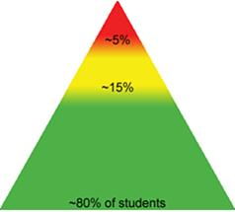
  - Typically, we expect to see about 80% of a school’s population in the low risk category.
  - Across schools, we saw a range of 49-64% of students at low risk for externalizing behaviors across the year and 56-74% of students at low risk for internalizing behaviors across the year
  - These data reflect the urgency of the PPIW model and the team’s focus on supporting students who are in need of targeted or intensive supports.
- In terms of change across the year, overall data indicate that the number of students identified as at moderate risk decreased, whereas the number of students identified as at high-risk increased.
  - There was notable variability when we examined this data at the grade level
    - Many grades had large decreases in students identified across risk categories across the year
  - Cross year screening data also highlight the important work that is occurring to build systems that support students with multiple risks and challenges. Screeners play a critical role in the identification and alignment of services for high needs students, and the number of students who were identified, and the consistency of these screening results across the year highlight a major strength of the PPIW program.
CLASS Data
- CLASS data represent a snapshot of foundational quality of interactions. Overall, these data indicate that there is moderate to strong foundational quality in the Classroom Organization domain across the three included schools.
  - There is notable variability at the school, classroom, and age group level, but overall quality of classroom organization is strong.
  - Teachers identified based on ODR data had similar variability
Prevention Specialist Logs
- Prevention Specialists are spending a majority of their time on planning, documentation, and individual student supports due to challenging needs.
- Prevention Specialists also spend more time on SAP supports than non-SAP supports, but there is variability across schools
  - We speculate that these variations are due to school-level contextual differences. It is critical that prevention specialists are able to attend to these context-specific differences, but we also need to ensure that we are able to capture the critical components of the PPIW program that are consistent across schools.

Lessons Learned
Year one represents a strong start to building the PPIW program. The data collected provide a snapshot of different areas PPIW is impacting.
Screener Lessons Learned:
- More data is needed to clearly link changes in student outcomes to PPIW and other student supports, and to document whether/how these supports are being provided systematically.
- Additional student level data (e.g., SSIS) may also be necessary to document whether the PPIW program is impacting student outcomes.
CLASS Lessons Learned:
- CLASS Classroom Organization data may represent an important tool for data-based decision- making, as they may highlight teachers who need additional consultation and/or PD supports, but additional training and supports may be required to make these data-based decisions.
- Additional measures of classroom practice may be necessary to measure the types of changes impacted by the PPIW program and PD and consultation processes, as the CLASS measures more distal, foundational aspects of general quality.
- The data suggests that the SPECS team will add individual student behavioral analysis data as an important marker of status and change in social-emotional and self-regulatory behaviors of students collected by prevention specialists team members.
Logs Lessons Learned:
- Log entries were highly variable, most likely due to the fact that this was a new measure that required modifications across the year and staff changes that may have impacted entries. Additional training and support, and alignment across tracking and data collection systems will be important parts of work moving forward in years 2 and 3 so that we can link critical prevention specialist data to implementation and outcomes.
Collectively, our lessons learned in year 1 indicate that we need more information that links the different components of the PPIW program, as well as more information about implementation of the program in general. This is to be expected, as implementation of any new model takes time and involves multiple stages as different components are put into place.
- Given that PPIW is being implemented along with PBIS and SAP changes, there is a critical need to understand implementation variables across these programs to be able to identify the critical active ingredients that can then be linked to positive changes in student, teacher, classroom, and family outcomes.
- There is also a need for data systems that link student data to services and teacher and prevention specialist data to consultation, PD, and collaboration.
We as a team should focus on building the systems that are needed to collect these data and support implementation, and emphasize the evaluation of these processes to ensure that the data we collect align with these priorities.

